The Inbetweeners – First Day
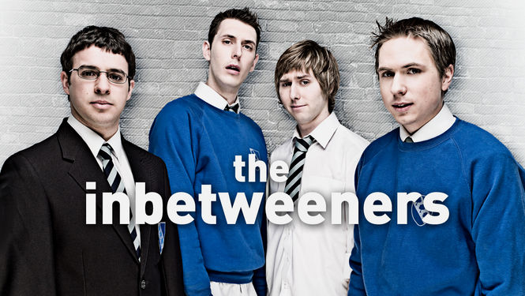
- While you are watching, write down the missing words in the subtitles
1. | 6.
2. | 7.
3. | 8.
4. | 9.
5. | 10.

- After you’ve watched the episode, answer these questions.
- Some typically British words are used in this episode. Explain what these words mean (in English) and explain when they are used (in which situation).
Word | Meaning | Used
Innit
Fad
Fit
Bruv

- Will is taken from a private school and sent to a public school. What’s the difference between private schools and public schools in England?
…………………………………………………………………………………………
- When Carli is very close to Simon, she smells that he is wearing ‘Lynx’. By what name do we know ‘Lynx’?
…………………………………………………………………………………………
- Find 3 other brands that use different names in Britain.
English name | Dutch name

- At one point, someone says the idiom ‘Beggars can’t be choosers’. What does this mean?
…………………………………………………………………………………………
- Find 5 other English idioms and explain what they mean.
English idiom | Meaning

- As in the Netherlands, you are only allowed to drink in England when you have a certain age. When is it legal for someone who’s 16 to drink?
…………………………………………………………………………………………
When is it legal for someone who’s 5 to drink?
…………………………………………………………………………………………

